Standard Operating Procedure for VAP Printing

**Potential Hazards and PPE**

Potential Hazard 1: High Voltages are used to run the transducer. Ensure all connections are secure. Never touch connection while the channel is on. (Max Voltage = 400 Vpp)

Potential Hazard 2: High Pressures are used to drive the material through the syringe. Ensure all airline supply connections are secure. Wear safety glasses in case of malfunction. (Max Pressure = 125 psi)

Potential Hazard 3: Materials used for printing may contain hazardous solvents or substances. Please handle material with proper PPE. This PPE is highlighted in their respective material preparation SOPs.

Potential Hazard 4: Heating can arise from over driving the transducer. Also, as high voltages are used, electronics can overheat. Please monitor all equipment to ensure overheating does not occur. (Max Heating = 100 C)

Potential Hazard 5: Moving parts on the printer can cause pinch points. Do not attempt to touch printer while running. Be sure to pause the print and turn off the electrical signal to the transducer before making and adjustments.

PPE: safety glasses, material dependent PPE (reference SDS and material preparation SOP)

**Prior to Experimentation**

0) Place appropriate signage so people are aware of experimentation.

1) Turn on:

* Power Strip
* Air Compressor
* Printer
* Function Generator
* Amplifier (verify gain is set to zero before turning on)
* Oscilloscope
* 200/1 Probe (Ensure switch it on, battery is not low, and set 200/1. If battery is low, use the wall charger to power it.)

2) Prepare printing material per respective SOP.

3) Prepare proper gcode per respective SOP and save to printer SD card. Open gcode to ensure proper stops were implemented correctly and completely. Insert SD card into printer.

4) Ensure everything is plugged in as shown in Figure 1. Ensure probe settings on oscilloscope are 200/1 for high voltage probe.

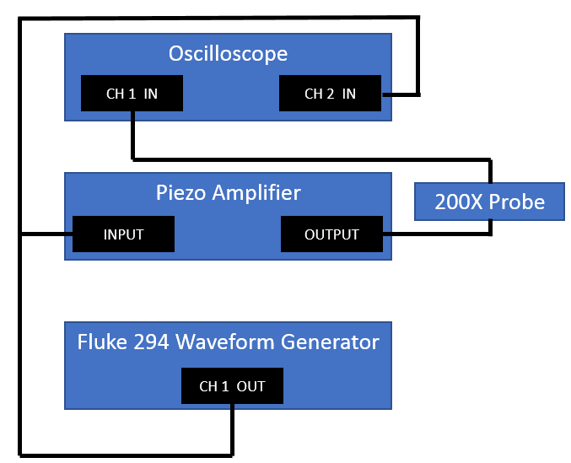

Figure 1: Schematic for Step 4 of “Prior to Experimentation”

5) Verify all printer components and stepper motors are connected properly, regardless if they are not used.

**Experimentation**

0) If running a test autonomously (the operator will not be present at any point in the test), place the “Experiment in Progress” Signage appropriately filled out in front of the printer. **NOTE**: **no test can be run without supervision by at least two people (experiment operator and their second) with energetic materials.**

1) Verify proper transducer signal:

* Change output of function generator to desired signal. Do not exceed 20 Vpp. You can change amplitude, frequency, etc. by hitting the respective button, typing in the value, and hitting enter.
* Verify signal by setting “Mode” to “Continuous” and turning on Channel 1. Ensure the output signal from the amplifier is as desired. Adjust amplitude by turning the knob on the amplifier. DO NOT EXCEED 400 V. Turn off channel 1.
* Set trigger mode to “Triggered” by pushing the mode button and selecting “Triggered”. Change Triggered/Gated settings by hitting the button to the right of the screen. Change cycles to 60000.
* Set the trigger to manual by pressing “Trig In” repeatedly pressing “Source” until MAN is displayed. Set Trigger level to 3 V.
* Turn on Channel 1. When pressing the “Man” button, ensure 60000 cycles of the desired signal are output by the amplifier. Turn off Channel 1.

2) Disconnect the probe from the output of the amplifier and connect transducer (ensure grounded properly), per Figure 2.

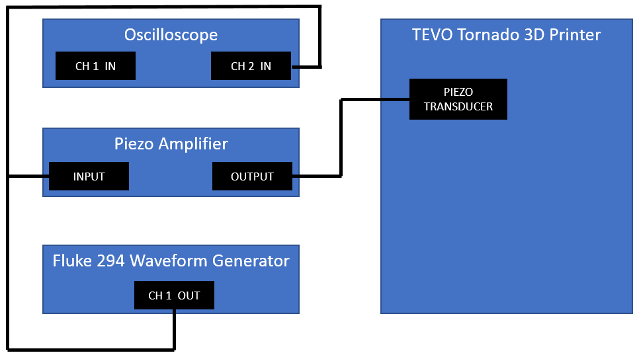

Figure 2: Schematic for Step 2 of “Experimentation”

3) Load material into syringe using a spatula. Make sure material is tightly packed with minimal gaps. Ensure material is near the tip of the syringe.

4) Load syringe onto printer. Before adjusting the back pressure system, ensure all hose clamps and connections are in place and tight. Connect back pressure system. Adjust pressure to the syringe to 90 PSI using the knob above the printer. Allow it to settle for 5 minutes. Pressure may be adjusted to ensure proper flow. Do not exceed 110 PSI.

5) Turn on Channel 1. Manually trigger the piezo until flow is achieved. If there is not enough room to see extrusion, raise 3D print head up on the printer by selecting “Main”, “Prepare”, “Move Axis”, “Move Z”, clockwise moves extruder away from the build plate. Turn off Channel 1.

6) Adjust TRIG to “EXT”. Under Mode, under “Triggered Settings”, adjust cycles to 1. Ensure input trigger signal is properly connected from printer as seen in Figure 3.

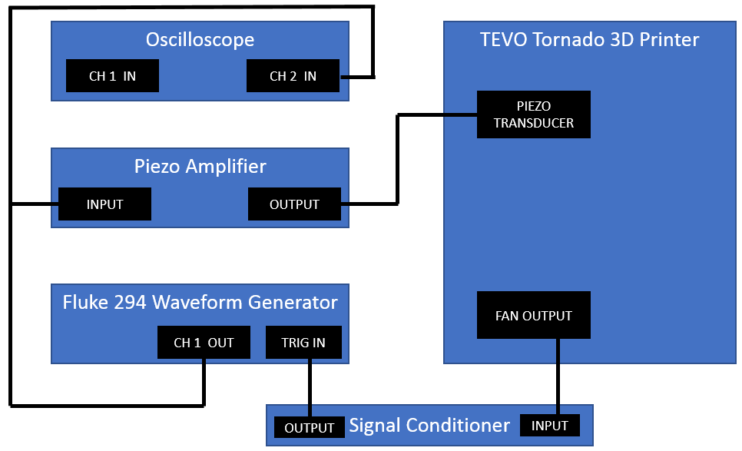

Figure 2: Schematic for Step 6 of “Experimentation”

7) Place glass slides on the print bed to be used as a substrate, secure using tape. Alternatively, use the black PTFE sheets as a substrate, secured with double-sided tape.

8) Turn on Channel 1. Run print file. Ensure transducer is being triggered at proper times by monitoring the output of the function generator on the oscilloscope. Monitor printing components to ensure not over heating.

9) After print file is complete, turn off Channel 1. Turn down pressure to the syringe using the knob on top of the printer. Turn down gain of the amplifier.

**After Experimentation**

1) Turn off:

* Air Compressor
* Printer
* Function Generator
* Amplifier (verify gain is set to zero before turning off)
* Oscilloscope
* 200/1 Probe (Ensure switch it on, battery is not low, and set 200/1)
* Power Strip

2) Dispose of printing material per respective material preparation SOP instructions.

3) Return any signage used.